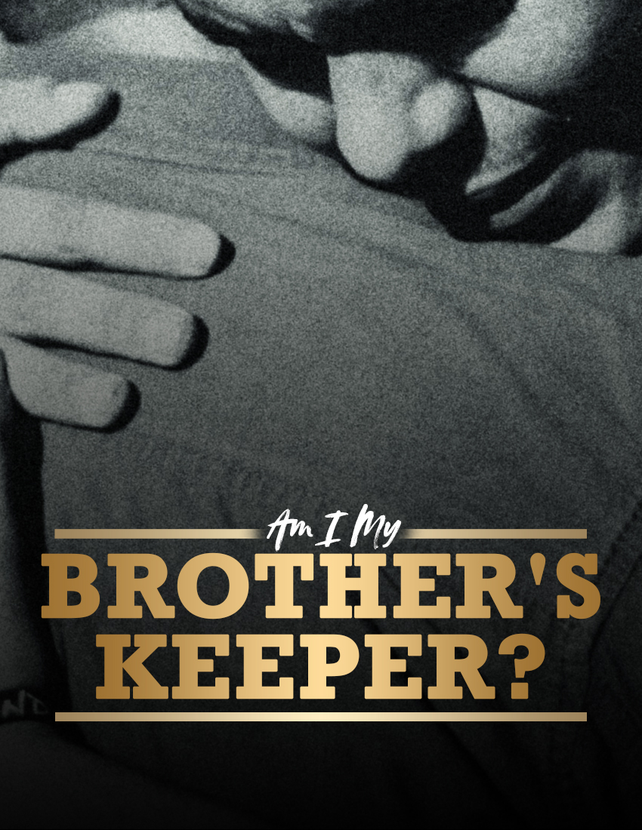

"AM I MY BROTHER'S KEEPER?"

Genesis 4:9

Link: https://executableoutlines.com/textual_sermons/gen4_9.html

INTRODUCTION
- Cain's question is perhaps one of the most thought-provoking ones in the Bible:
  - As we can remember in the book of Genesis, Cain had killed his brother because God had accepted Abel's offering, but not his own - Gen 4:3-8
  - Cain's response when the Lord questioned about Abel was:
"Am I my brother's keeper?" (Gen 4:9)
- This is a question we would do well to ask ourselves today...
  - Are we our brother's keeper?
  - Do we have a responsibility to watch out for and care for one another?
[When one reads the New Testament, it is clear that the answer is affirmative in nature. Yes! I am my brother’s keeper. You are your brother’s keeper. And, there are numerous passages that give emphasis to that…]
- WHY AND HOW ARE WE RESPONSIBLE FOR ONE ANOTHER?
  - WHY? BECAUSE WE ARE TO "LOVE ONE ANOTHER"...
    - As commanded by Jesus - Jn 13:34-35; 15:12,17
    - As taught by Paul - Ro 13:8; 1Th 4:9
    - As instructed by Peter - 1Pe 1:22
    - As stressed by John - 1Jn 3:11 (note v.12), 23; 4:7,11-12; 2Jn 5
  - HOW WE SHOW OUR LOVE FOR ONE ANOTHER...
    - We are to "receive one another" - Ro 15:7
    - We are to "edify another" - Ro 14:19
    - We are to "serve one another" - Ga 5:13
    - We are to "bear one another's burdens" - Ga 6:1-2
    - We are to be "forgiving one another" - Ep 4:32
    - We are to be "submitting to one another" - Ep 5:21
    - We are to "exhort one another" - He 3:12-13
    - We are to "consider one another" - He 10:24-25
    - We are to be "hospitable to one another" - 1Pe 4:8-10
- EVALUATING OUR ROLE AS OUR BROTHER'S KEEPER
  - WHEN ONE BECOMES A BROTHER...
    - Do we accept them into God's family or do we shun them?- Ro 15:7
      - Are they properly assimilated into the family life of the church?
      - Do they remain on the fringe?
      - If we do not even know their names, we can be certain that we fall short as a brother's keeper!
    - Do we edify them, or put stumbling blocks in their way? - Ro 14:19
      - As individuals, we are "body-builders", encouraging the members of the body.
      - Or are we like cancer, weakening the members of the body of Christ?
        - By our own actions
        - By our words, attitudes, etc.
    - Do we submit to them, or arrogantly rule over them? - Ep 5:21
    - Do we serve them in love, or expect them to serve us? - Ga 5:13
    - Do we demonstrate hospitality to them? - 1Pe 4:8-10
      - By visiting them in their need?
      - By inviting them into your home (or accepting invitations to their home)?
[These are very important questions we should be asking ourselves today. In the Christian world, we have become too religion-focused instead of being people or “brother-focused”, let us change that together! We become someone’s brother if we do these. Accept, edify, submit, serve, demonstrate hospitality.]
  - WHEN A BROTHER IS OVERTAKEN IN A FAULT...
    - Do we even consider their thoughts and circumstances? - He 10:24-25
      - Are we even aware of who they are?
      - Are we ignorant of their problems? If so, why?
        - Maybe it is because we don't assemble enough ourselves
        - We may "wonder about them", but that is not sufficient!
      - Do they drift away, with no one making an effort to reach them?
    - Do we exhort them to keep their hearts from becoming hardened by sin? - He 3:12-14
      - Or are we afraid to confront them, fearing they might run away?
        - They are unlikely to flee if we sincerely love them and approach them with humility.
        - If they do, they are running away from God, not you!
      - Remember, such exhortation is to be done daily! Perhaps we wait too long...
    - Are we willing to bear their burdens? - Ga 6:1-2
      - So as to help them overcome and become stronger
      - Or do we rather not be bothered?
    - Are we quick to forgive them when they repent? - Ep 4:32
      - Some have kept from repenting and returning because of the fear of not being forgiven and accepted back into the family.
      - Do we show that we are willing to receive them with open arms and to forgive them completely?

CONCLUSION
- How we answer such questions may reveal how well or poorly we are...
  - Fulfilling our responsibility to be our brother's keeper
  - Living up to the one responsibility we have that includes all others: to love one another as Christ loved us - Jn 13:34-35
- If we have failed to be our brother's keeper, we need to...
  - Repent of our lack of concern, our inactivity, or whatever has hindered us
  - Confess our shortcomings in this area to God
  - Resolve to apply with zeal these "one another" passages!

To those of us who are already committed and planted in this church, are you your brother's keeper? To the others, are you identified with a congregation whereby you can be a working member who both cares for those in the family and is being cared for by them? If not yet, be part of us! Let us all be keepers of one another.
I hope this study has inspired you to re-examine your responsibility to your Christian brothers and sisters...

