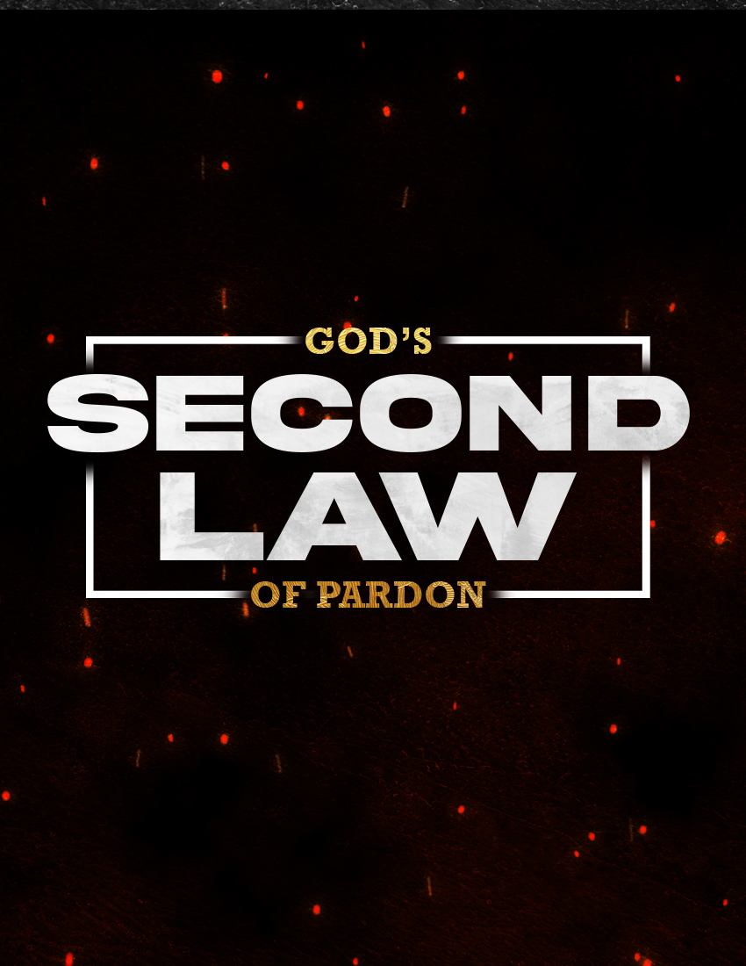

"GOD'S SECOND LAW OF PARDON"

Acts 8:22

Link: https://executableoutlines.com/textual_sermons/ac8_22.html

INTRODUCTION
- Different guidelines on how to obtain forgiveness are actually revealed in the Scriptures...
  - To alien sinners outside of Christ - cf. Ac 2:38; 22:16
  - To erring Christians guilty of sin - cf. Ac 8:22; 1Jn 1:19
- Some have referred to the difference as "God's Two Laws Of Pardon"...
  - For the alien sinner, there is God's first law of pardon
    - Hear the gospel
    - Believe that Jesus is the Christ, who died for our sins
    - Repent of sins
    - Confess faith in Christ
    - Be baptized for the remission of sins
  - For the erring Christian, there is God's second law of pardon
    - Repent of sins
    - Pray to God
    - Confess sins to God
[We frequently spend a lot of time explaining the first law when we evangelize. We should be as concerned with the second law as Christians wanting to maintain our connection with God. Take a look at "God's Second Law Of Pardon" in more detail...]
- WHAT CHRISTIANS MUST DO
  - WE MUST REPENT OF SINS...
    - Note that repentance is required in both laws of pardon - cf. Ac 2:38; 8:22
    - What does repentance entail? It literally means "a change of mind."
      - "signifies to change one's mind or purpose" - Vine
      - "this change of mind involves both a turning from sin and a turning to God" - ibid.
    - Thus, it involves making the decision to quit sinning.
      - Just as the alien sinner is called to do so in becoming a Christian
      - So the erring Christian must do to return to the Lord
    - Repentance is produced by "godly sorrow" - cf. 2Co 7:9-10
      - A sorrow for having sinned against God - e.g., Ps 51:4
      - As opposed to worldly sorrow for getting caught or being exposed
    - Repentance is also prompted by God's goodness - Ro 2:4
      - Awareness of God's grace and kindness should lead us to repent
      - Frequent meditation on the Word of God will help in this regard
    - Repentance will be manifested by a remarkable change - 2 Co 7:11
      - Such as diligence and zeal to do right
      - Such as indignation for our sins and a desire to make right
  - WE MUST PRAY...
    - So Peter told Simon when he sinned after having believed and was baptized - Ac 8:22
    - Compare this to God's first law of pardon
      - Baptism is an act of faith, in which we make an appeal - 1Pe 3:21
      - Prayer is also an act of faith, as we appeal for forgiveness
      - Yet alien sinners are commanded to repent and be baptized - Ac 2:38
      - While erring Christians are commanded to repent and pray
    - The difference is understandable
      - Before baptism, one is not a child of God - Ga 3:26-27; cf. Jn 3:3-5
      - After baptism, prayer is a privilege for those who are God's children - cf. Ga 4:6-7
    - Praying is effective for the Christian because of our two intercessors
      - Jesus, who understands our feelings - He 2:17-18; 4:14-16; 7:24-25
      - The Holy Spirit, who communicates our feelings - Ro 8:26-27
    - As we pray, we must do so with humility
      - Compare the difference between the Pharisee and the publican - Lk 18:9-14
      - God favors the humble and contrite in spirit - Ps 34:18; Isa 66:1-2
  - WE MUST CONFESS...
    - So John wrote to Christians, to experience God's forgiveness - 1Jn 1:9
    - Compare this to God's first law of pardon
      - Where confession is commanded, but not confession of sins
      - Instead, confession is made concerning Jesus Christ - Ro 10:9-10; cf. Ac 8:37
    - Understanding the word "confess"
      - Comes from the Greek word homologeo
      - "lit., to speak the same thing; to agree with, admit" - Vine
      - In regards to sin, it means to openly and honestly admit sin without hiding it or offering excuses for it - e.g., Dan 9:4-6,10-11,15
    - Confession of sins should be made...
      - Continuously - for John literally wrote "If we keep confessing our sins..."
      - For both known and unknown sins - e.g., Ps 19:12
      - Always to God, sometimes to each other - cf. Jm 5:16

- WHAT GOD WILL DO
  - GOD WILL BE FAITHFUL...
    - As John promised in encouraging us to confess our sins - 1Jn 1:9
    - This means He will be true to His promise
    - What promise? The promise found in the prophecy of the New Covenant!
      - Found in Jeremiah, repeated in Hebrews - Jer 31:31-34; He 8:7-13
      - "For I will be merciful to their unrighteousness, and their sins and their lawless deeds I will remember no more." - He 8:12
  - GOD WILL BE JUST...
    - As John promised in encouraging us to confess our sins - 1Jn 1:9
    - This means He will be righteous in forgiving our sins
    - How can this be? By virtue of the cleansing blood of Jesus!
      - A cleansing alluded to earlier - 1Jn 1:7
      - So God can be both just and justifier of those who have faith in Christ - Ro 3:24-26
  - GOD WILL FORGIVE AND CLEANSE...
    - He will "forgive us our sins" - 1Jn 1:9
      - "The word 'forgive' describes the act of canceling a debt and the restoration of the debtor" - Kistemaker
      - No longer will the guilt of our sins be held against us!
    - He will "cleanse us from all unrighteousness" - 1Jn 1:9
      - "The word 'cleanse' refers to making the forgiven sinner holy so that he is able to have fellowship with God" - Kistemaker
      - The word "all" is reassuring; no sin is beyond God's ability to forgive the penitent Christian who confesses their sin!

CONCLUSION
- The Christian who repents, prays, and confesses will be forgiven under God's second law of pardon…
  - Experience the continual cleansing of the blood of Christ!
  - Enjoy the blessedness of knowing your sins are forgiven!
- Do not hesitate to obey God's second law of pardon…
  - You can have the same joy of salvation as when you were baptized into Christ!
  - For you rise from prayer as cleansed from sin as when you arose from the watery grave!

Take advantage of "God's Second Law Of Pardon" if you wish to have the same delight and assurance of salvation as that new infant in Christ who emerges to a new existence!

"Seek the Lord while He may be found, Call upon Him while He is near. Let the wicked forsake his way, And the unrighteous man his thoughts; Let him return to the Lord, And He will have mercy on him; And to our God, For He will abundantly pardon." - Isa 55:6-7

