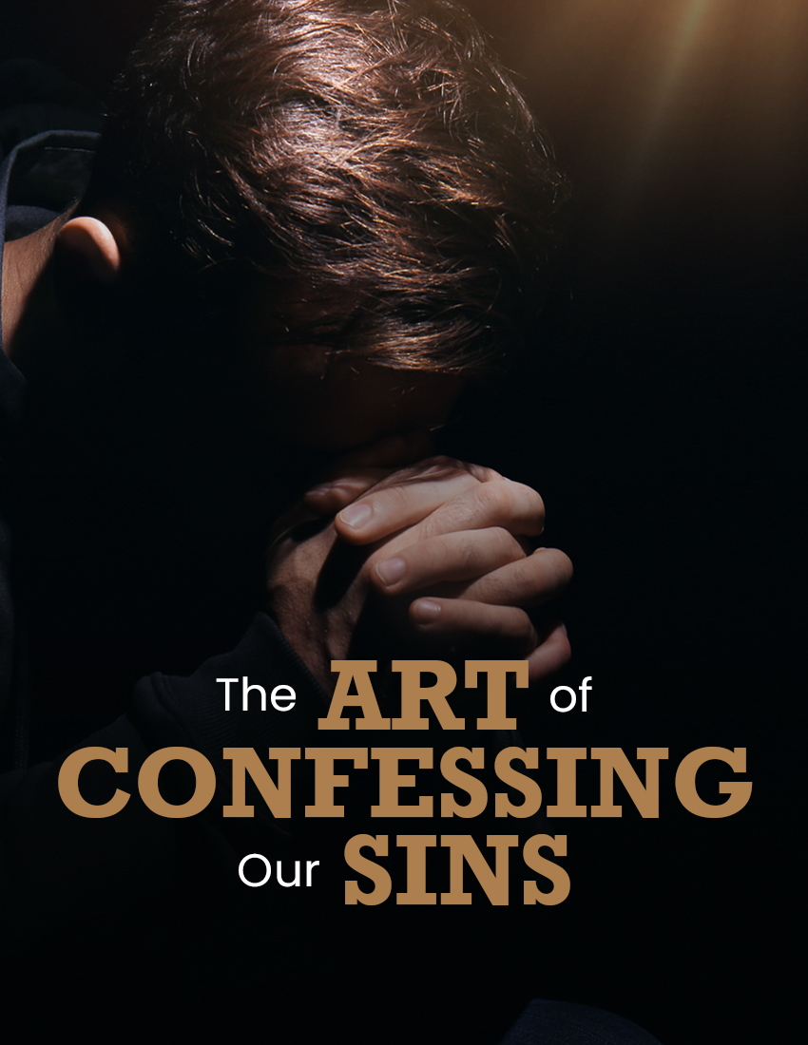

"THE ART OF CONFESSING OUR SINS"

Psalms 51:1-19

INTRODUCTION
- Do you remember the joy and the relief you experienced when you were baptized?
  - Knowing that your sins had been washed away by the blood of Christ?
  - Knowing that you then stood before God holy and without blame?
- -- Wouldn't it be great to experience that same joy and relief, time and again?There is no reason why you cannot!
  - Even though you may have sinned terribly after your baptism
  - For God has made provision whereby we can enjoy the continual cleansing of the blood of Christ!
- Not by being baptized again and again...
  - But by confessing our sins to God - cf. 1Jn 1:9
  - For God who is faithful and just has promised to forgive our sins!
- -- Just as we were raised from the grave of baptism cleansed by the blood of Jesus, so we can rise from our prayers knowing that we have been cleansed from all unrighteousness!The key is to confess our sins...
  - But how does one do that effectively?
  - Are there some things to keep in mind as we confess our sins?
- In Psalms 51, we have what David wrote after he was guilty of adultery with Bathsheba...
  - He provides an example of how one should confess their sins to God
  - He provides what I like to call "The Art Of Confessing Our Sins"
[How should one go about confessing their sins to God? From the example of David, a good place to begin is...]
- APPEAL TO GOD'S MERCY AND LOVE (1-2)
  - NOTE THE BASIS OF DAVID'S PLEA FOR FORGIVENESS...
    - "according to Your lovingkindness"
    - "according to the multitude of Your tender mercies"
  - THE PARDON WE SEEK SHOULD HAVE AS ITS BASIS...
    - Not in the merit or worthiness of man
    - But in the goodness and grace of God!
  - AS WE SEEK "WASHING" AND "CLEANSING" FROM OUR SINS...
    - Don't base our appeal on our past accomplishments
      - E.g., how much we have done for the Lord
      - E.g., how long we have been a member of His church
    - But upon the goodness and mercy of God!
      - Appeal to His mercy and grace!
      - Knowing that He is slow to anger and abounding in mercy! - cf. Ps 103:8-10
- ACKNOWLEDGE OUR SINS TO GOD (3-4)
  - NOTE HOW DAVID ACKNOWLEDGED HIS SIN...
    - He did not try to hide it: "my sin is ever before me"
    - He admitted that it was a sin against God Himself: "Against You, You only, have I sinned, and done this evil in your sight"
      - While it is true he had sinned against Bathsheba, Uriah, his own wife...
      - ...David knew that it was ultimately against God Himself!
    - He accepted the condemnation of God against him
      - That God was both "just" and blameless" in judging him
      - As God did when He sent Nathan to condemn him
  - AS WE CONFESS OUR SINS...
    - Appreciate that this is key to receiving God's grace - cf. 1Jn 1:9
    - Acknowledge the sin; while we may at times simply confess to be sinners, it never hurts to actually mention the sin for which we seek forgiveness
    - Understand that all sin is ultimately a sin against God Himself!
    - Don't fault God (His Word or His messengers) when we are exposed and condemned for our sins!
- ]UNDERSTAND WHERE WE ARE AND WHERE GOD WANTS US (5-6)
  - UNTIL FORGIVEN, ONE IS DEEP IN SIN...
    - Using hyperbole so common in poetic language, David describes the depravity in which he finds himself
    - He is not trying to escape responsibility by saying he was born that way; only that he knows he is utterly sinful
  - BUT GOD DESIRES MUCH MORE...
    - David knew that God wanted:
      - "truth in the inward parts"
      - "wisdom in the hidden parts"
    - -- Again, figurative hyperbole illustrating that truth and wisdom are to be as pervasive as sin had been!David knew that God desired to provide more than just forgiveness, He also desires:
      - Total restoration, with understanding and wisdom on our part
      - That we be equipped for faithful service
- PRAY FOR RENEWAL AND RESTORATION (7-12)
  - DAVID DESIRED MORE THAN JUST FORGIVENESS OF SIN...
    - He does pray for forgiveness, using figurative language in asking God...
      - To purge him with hyssop - Ps 51:7
      - To wash him whiter than snow - Ps 51:7
      - To hide His face from his sins - Ps 51:9
      - To blot out all his iniquities - Ps 51:9
    - But he also sought for more; he desired...
      - Joy and gladness - Ps 51:8
      - A new heart, and renewal of a steadfast spirit - Ps 51:10
      - Continuation of God's presence and Spirit - Ps 51:11
  - -- As summarized in verse 12: "Restore to me the joy of Your salvation, and uphold me with Your generous Spirit."AS WE CONFESS OUR SINS...
    - We should look to God for more than just forgiveness!
    - We should also ask for:
      - A complete renewal and total restoration!
      - A return to "the joy of salvation" (that joy experienced when we first obeyed the gospel! - e.g., Ac 8:35-39)
- RESOLVE TO OFFER GRATEFUL SERVICE (13-17)
  - DAVID RESOLVES...
    - To teach other sinners and transgressors - Ps 51:13
    - To praise God for His righteousness in delivering him from sin - Ps 51:14-15
      - Knowing that God delights in something more than animal sacrifices - Ps 51:16
      - A broken spirit and contrite heart is what really pleases God - Ps 51:17; cf. Isa 66:1-2; 57:15
  - SUCH RESOLUTION IS IN KEEPING WITH TRUE REPENTANCE...
    - For God desires more than just forgiveness, but total restoration - cf. Ps 51:6
    - And zealous service is indicative of true repentance, as taught in 2Co 7:10-11
  - AS WE CONFESS OUR SINS...
    - We should look beyond obtaining forgiveness for past sin
    - We should look beyond obtaining present joy and gladness of heart
- PRAY FOR GOD'S PURPOSES (18-19)
  - DAVID OFFERED A PRAYER REGARDING GOD'S PURPOSES...
    - That God would fulfill His purpose for Zion - Ps 51:18
    - That God would be pleased with Israel's sacrifices - Ps 51:19
  - AS WE CONFESS OUR SINS...
    - We should not be selfish, praying for only our needs
    - What about God's desires? His purposes?
-- As Jesus taught us in "The Lord's Prayer", it is important to pray for God's will as well as our own (cf. "Thy Will be done on earth, as it is in heaven")

CONCLUSION
- I hope I have not made the practice of confessing sins sound complicated...
  - Certainly there are occasions where a simple "I have sinned..." may suffice
  - As illustrated in the prayer of the tax collector - Lk 18:13-14
- Yet if we desire to be less self-centered in confessing our sins, we can follow David's example:
  - Appeal to God's mercy and lovingkindness
  - Acknowledge our sins to God
  - Understand where we are and where God wants us
  - Pray for renewal and restoration
  - Resolve to offer grateful service
  - Pray for God's purposes
- By praying as David did, we are to sure to experience two things:
  - Forgiveness itself
  - The joy of forgiveness
-- As David expressed in Ps 32:1-5, written after receiving forgiveness for his sins
The Christian who confesses his sins is the truly happy individual ("Blessed is he whose transgression is forgiven..."), for they have the assurance of salvation (cf. 1Jn 1:9).
Have you confessed your sins to God today?

